

PROJECT MANAGEMENT | CAD DEPARTMENT

AutoCAD LT Setup Document

**Project Name:** CAD Setup

**Project Manager Name:** David Ketchum

**Project Sponsor:** David Ketchum

**Project Team Member Names:** All CAD Users

**Date:** 06.07.2017

**Prepared by:** Alex Lundin

# Table of Contents

## Purpose

## Steps

# Setup

## Purpose

This file will provide step by step instructions to configure AutoCAD software to Wattstopper standards. Every setting necessary to create Wattstopper drawings will be covered. The Setup document is a living manuscript and may be updated as the need arises. These guidelines are subject to change at any time and are ever evolving. Changes to this text will be posted, to the H Drive, as they become available.

## Steps

* 1. **Copy WS_Blocks folder from H Drive to C Drive**
     1. Type either location below into windows explorer (or cntrl-click)

H:\Drawings

P:\1 AutoCAD Main

* + 1. Copy WS_Blocks
    2. Paste into C:\

**C:\**

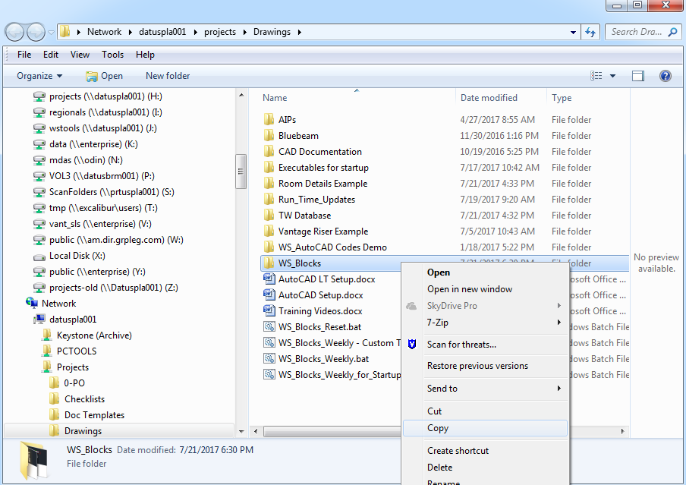

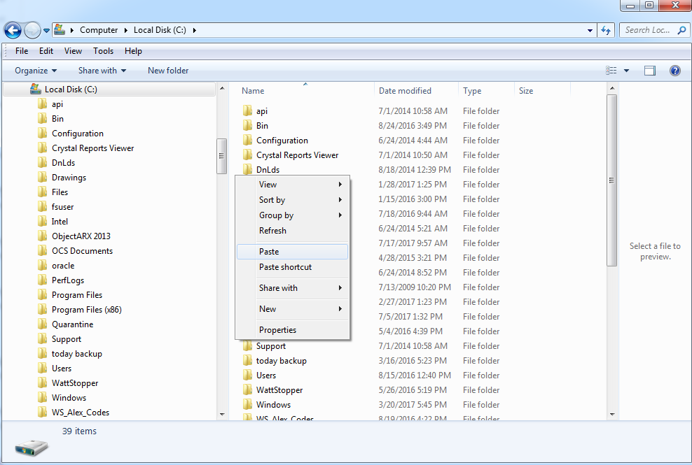

* 1. **Open AutoCAD**
     1. Navigate to Start menu
     2. Click All Programs
     3. Click Autodesk Folder
     4. Click AutoCAD-20XX-Enlgish
     5. ** Make sure to choose regular AutoCAD rather than architecture or mechanical

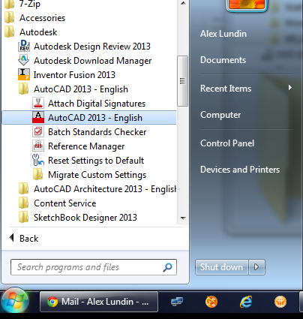

* 1. **Open Options**
     1. Type options into the command line
     2. Press enter

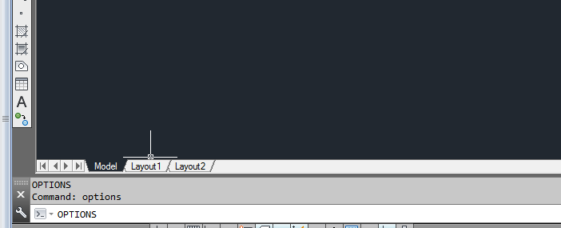

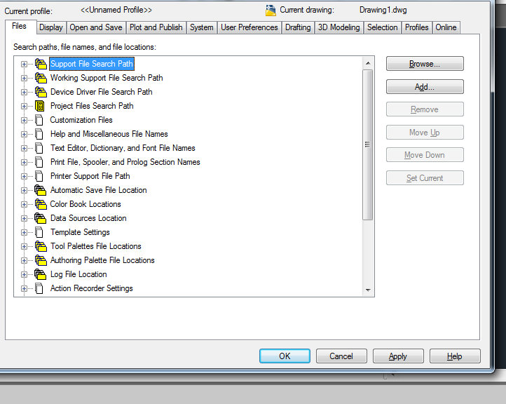

* 1. **Update Paths and Locations and change Save settings**
     1. Click + on Support File Search Path
        1. Add these four locations

C:\WS_Blocks\Default

C:\WS_Blocks\Default\LISP

C:\WS_Blocks\Default\ToolPallete\Palettes\Layout Blocks

C:\WS_Blocks\Default\ToolPallete\Palettes\Layout Blocks\Layout Block Definitions

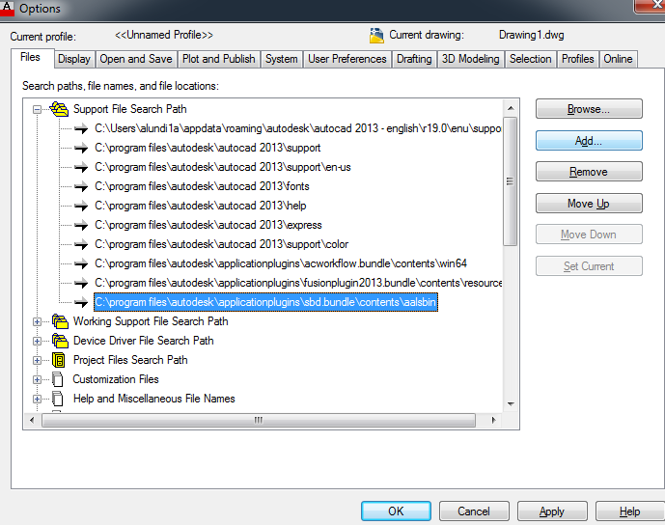

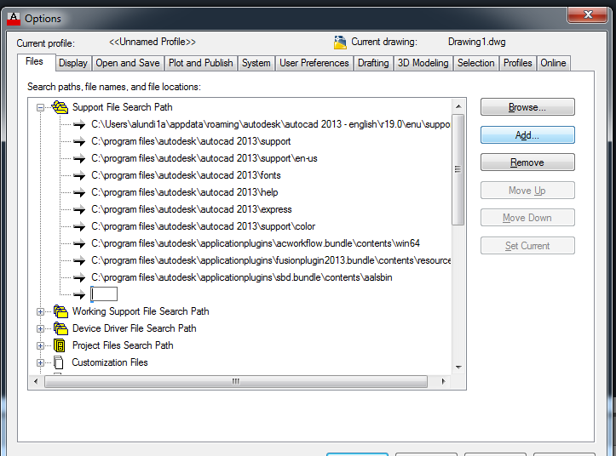

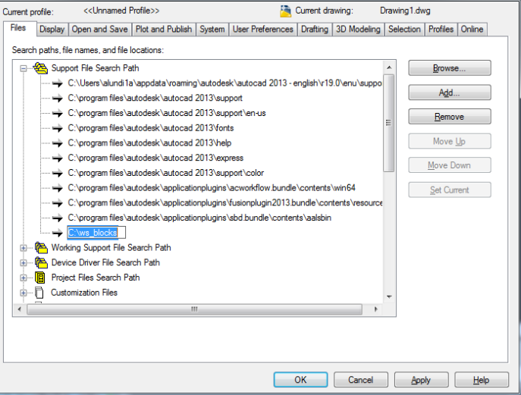

* + 1. **Click + Printer Support File Path (AutoCAD defaults to the locations below, if not then change them to match)**
       1. Click + on Plot Style Table Search Path
       2. Add this Location

C:\WS_Blocks\Default\Plotters

* + 1. **Click + on Automatic Save File Location**
       1. Remove default then replace with this location

C:\WS_Blocks\Autosaves

* + 1. **Click + on Template Settings**
       1. **Click + on Drawing Template File Location**
          1. Add this location

C:\WS_Blocks\Default\Templates

* + - 1. **Click + on Sheet Set Template File Location**

C:\WS_Blocks\Templates

* + - 1. **Click + on Default Template File Name for QNEW**

C:\WS_Blocks\Default\Templates \WATTSTOPPER.dwt

* + 1. **Click + on Tool Palette File Locations**
       1. Add these locations

C:\WS_Blocks\Custom\ToolPallete

C:\WS_Blocks\Default\ToolPallete

* + 1. **Click + on Customization Files**
       1. **Click + on Main Customization Files**
       2. Add this location

C:\WS_Blocks\Custom\CUI_Custom\WSMAIN.cuix

* + - 1. **Click + on Enterprise Customization Files**
      2. Add this location

C:\WS_Blocks\Default\CUI\WSENTERPRISE.cuix

* + 1. **Click Display tab in the top row of the options panel**
       1. Uncheck Display printable area
       2. Uncheck Display paper background

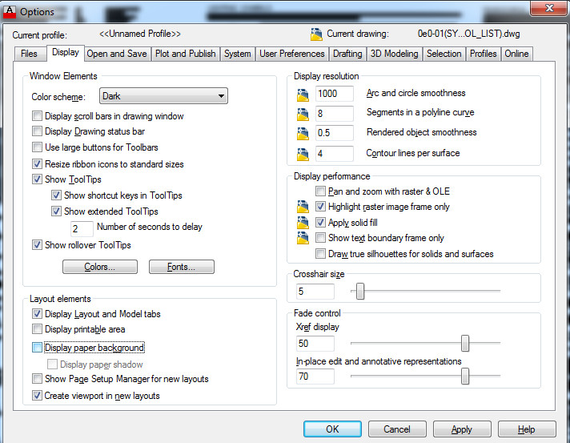

* + 1. **Click Open and Save tab in the top row of the options panel**
       1. Change save as setting to AutoCAD 2010/LT2010 (*.dwg)
       2. Check Automatic Save box
          1. Set to 5 minutes between saves
       3. Change the file extension box to “dwg”

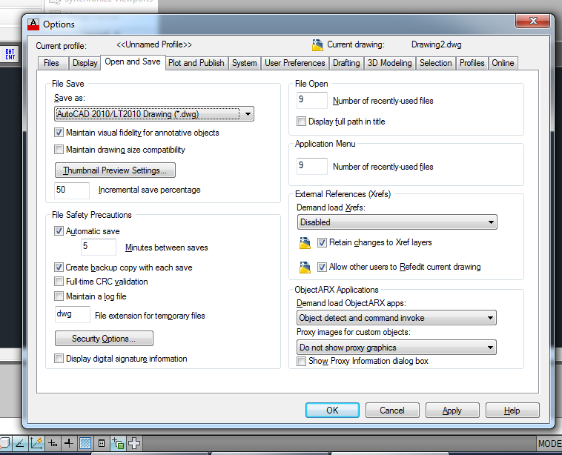

* + 1. **Click Plot and Publish tab in the top row of the options panel**
       1. Change use as default output device to “DWG To PDF.pc3”

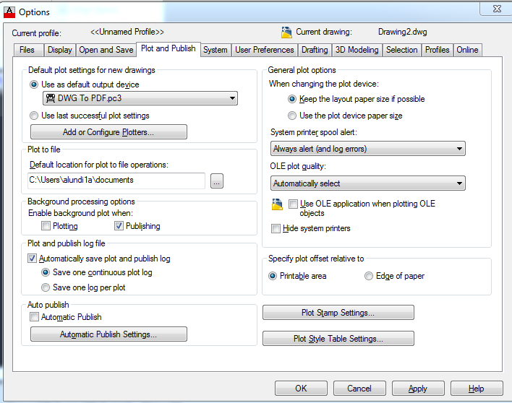

* + 1. **Click 3D Modeling tab in the top row of the options panel**
       1. Uncheck Display the ViewCube
          1. 2DWireframe visual Style
          2. All other Visual Styles
       2. Click Apply

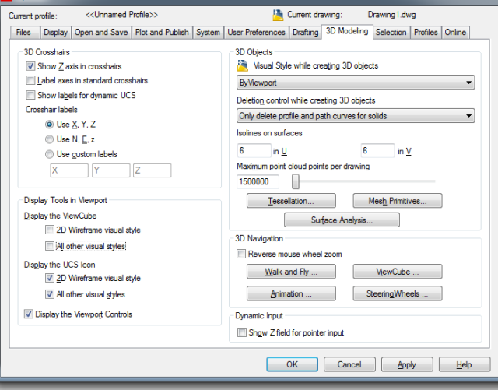

* 1. **Increase Hardware Acceleration**
     1. Type GRAPHICSCONFIG into command line
     2. Check Enable Hardware Acceleration at the top

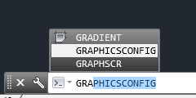

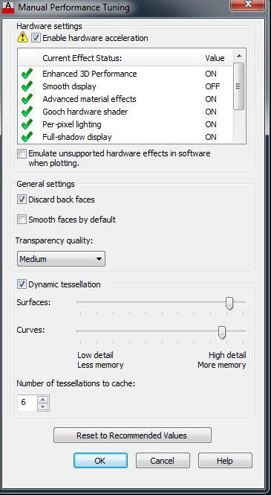

* 1. **Show Workspaces**
     1. Click drop down in top left of screen
     2. Click Workspace option
     3. Open the Workspace Dropdown
     4. Choose Wattstopper

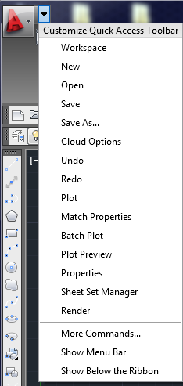

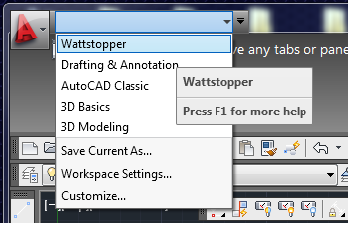

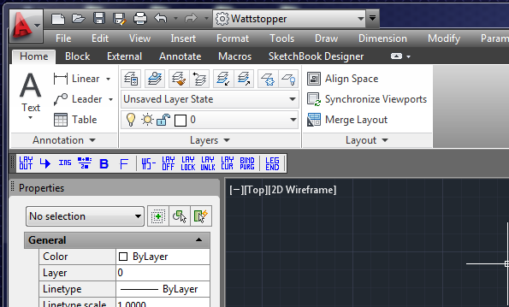

Your AutoCAD station now has all the custom information loaded. From here, you are free to set the Workspace and Toolbars to your preference. The following example shows a way to configure the Workspace.

* 1. **Set up Workspace and Toolbars**
     1. Open Workspace Settings
     2. With all Workspaces selected, check Automatically save workspace changes (you can turn this off after configuring these settings to protect your workspaces)
     3. Change the Workspace to Drafting and Annotation or Wattstopper (top left of screen)
     4. Right click tool palette (ctrl + 3 to show if hidden)
     5. Select anchor right >
     6. Drag the Wattstopper toolbar to the bottom row of the Ribbon
     7. Right click the lock in the bottom right hand corner
     8. Lock the Workspace
     9. Follow these same steps, but click unlock to allow movement of toolbars

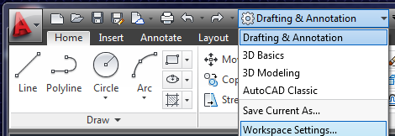

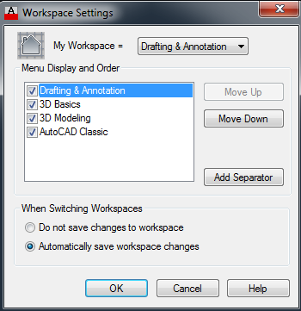

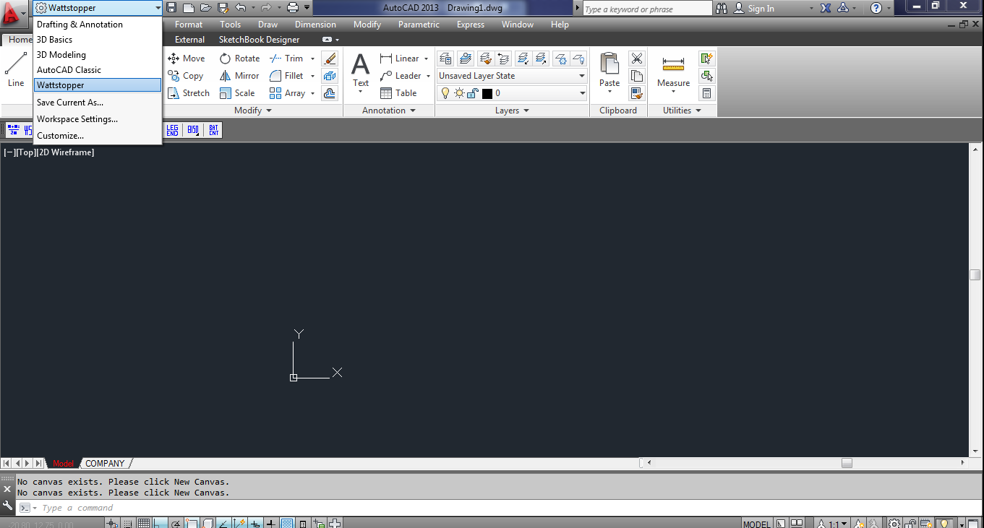

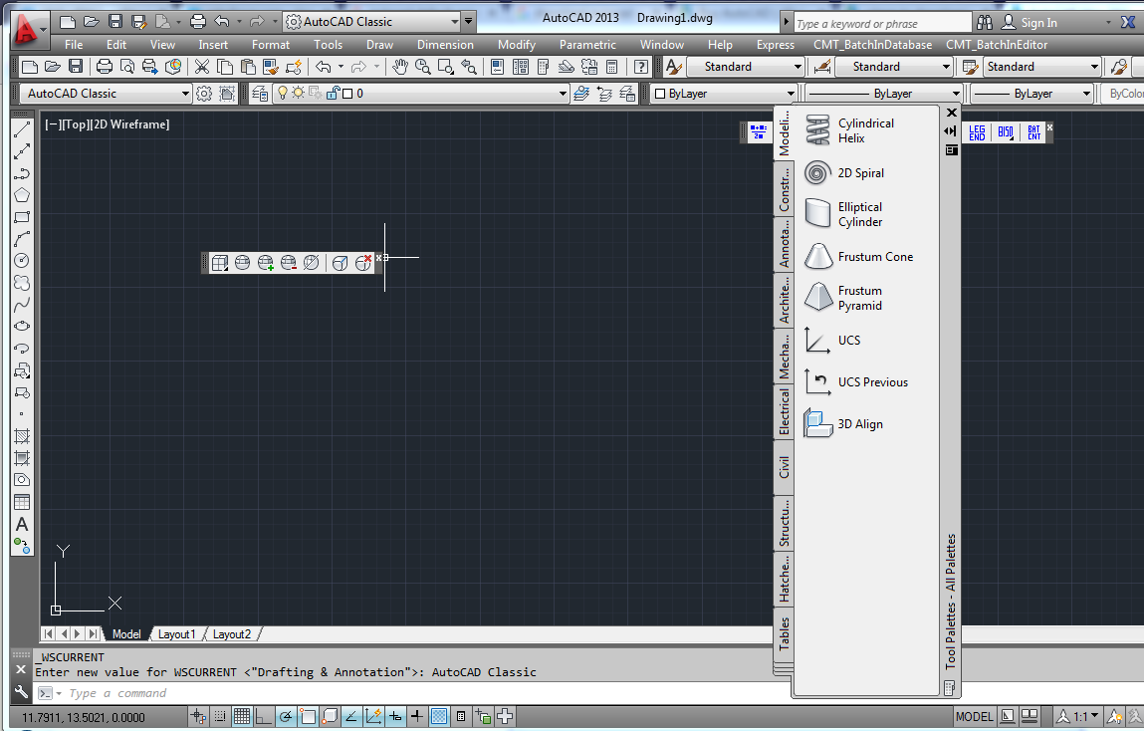

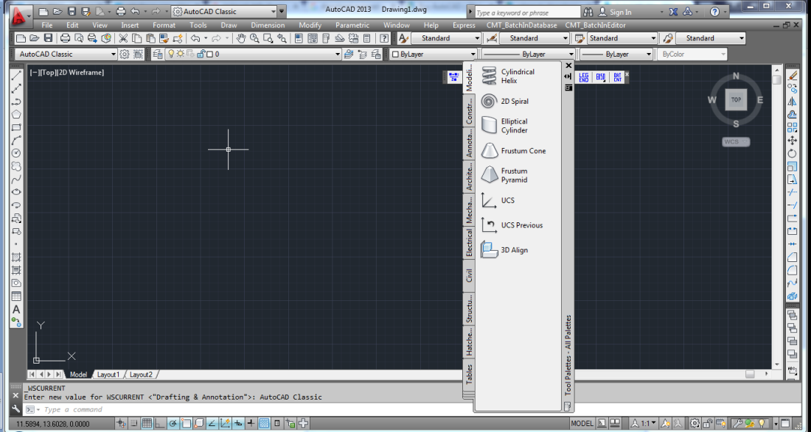

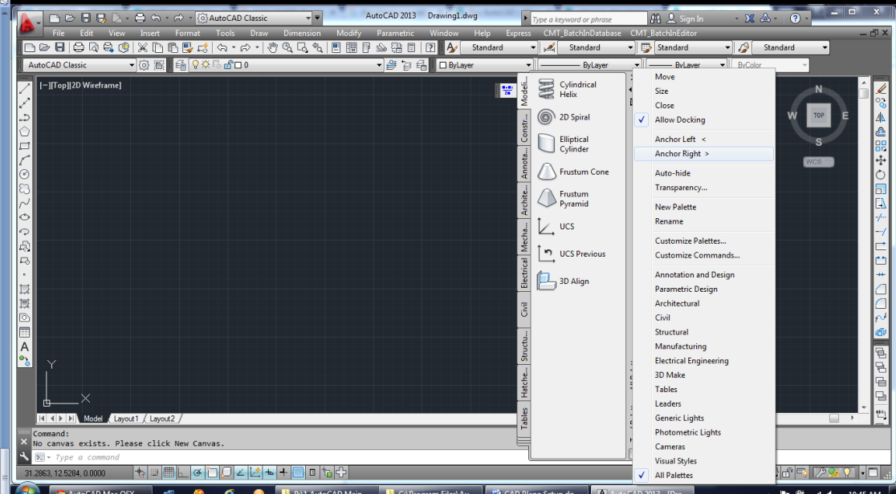

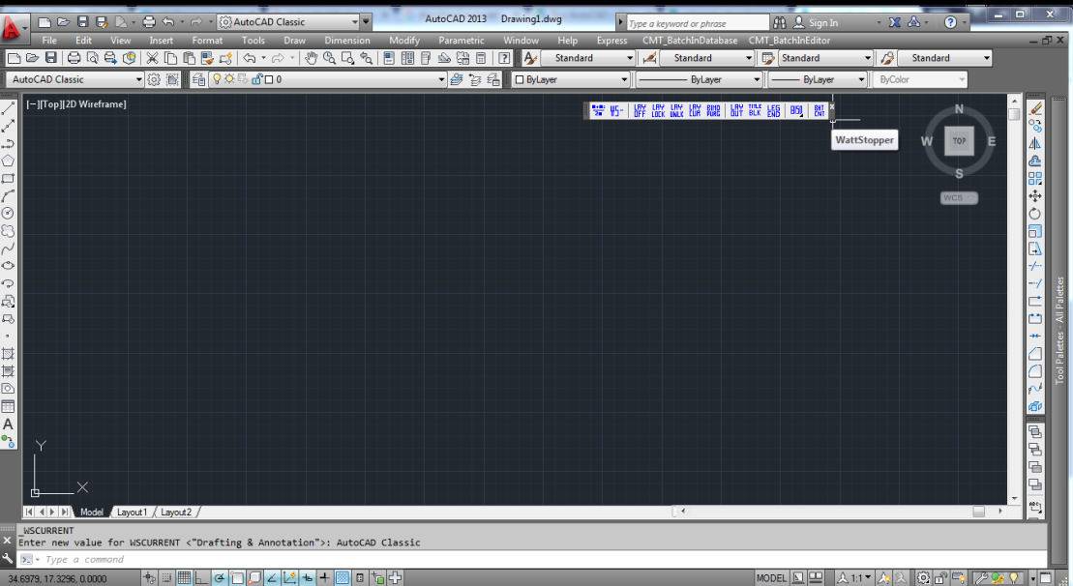

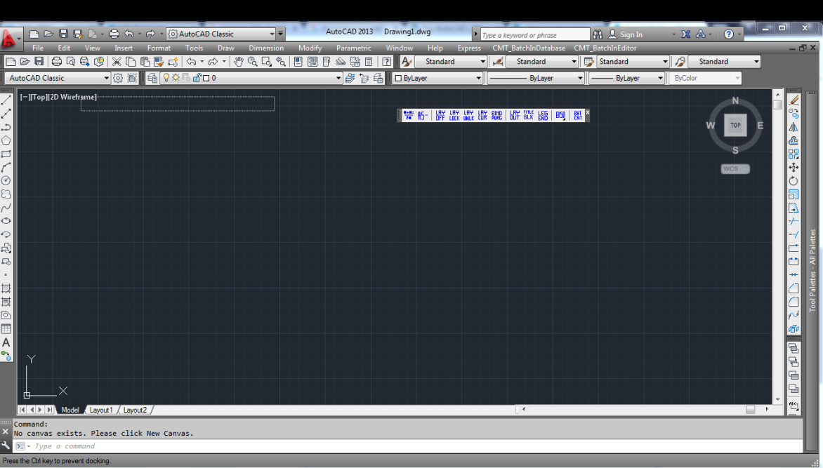

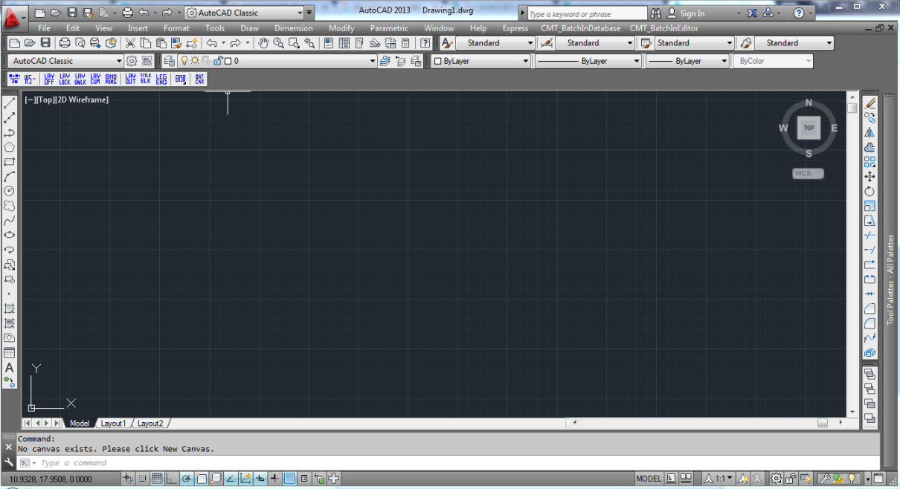

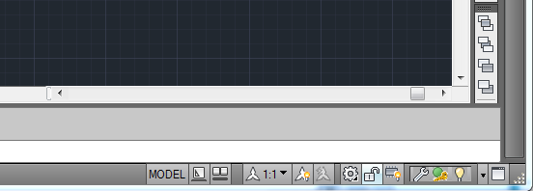

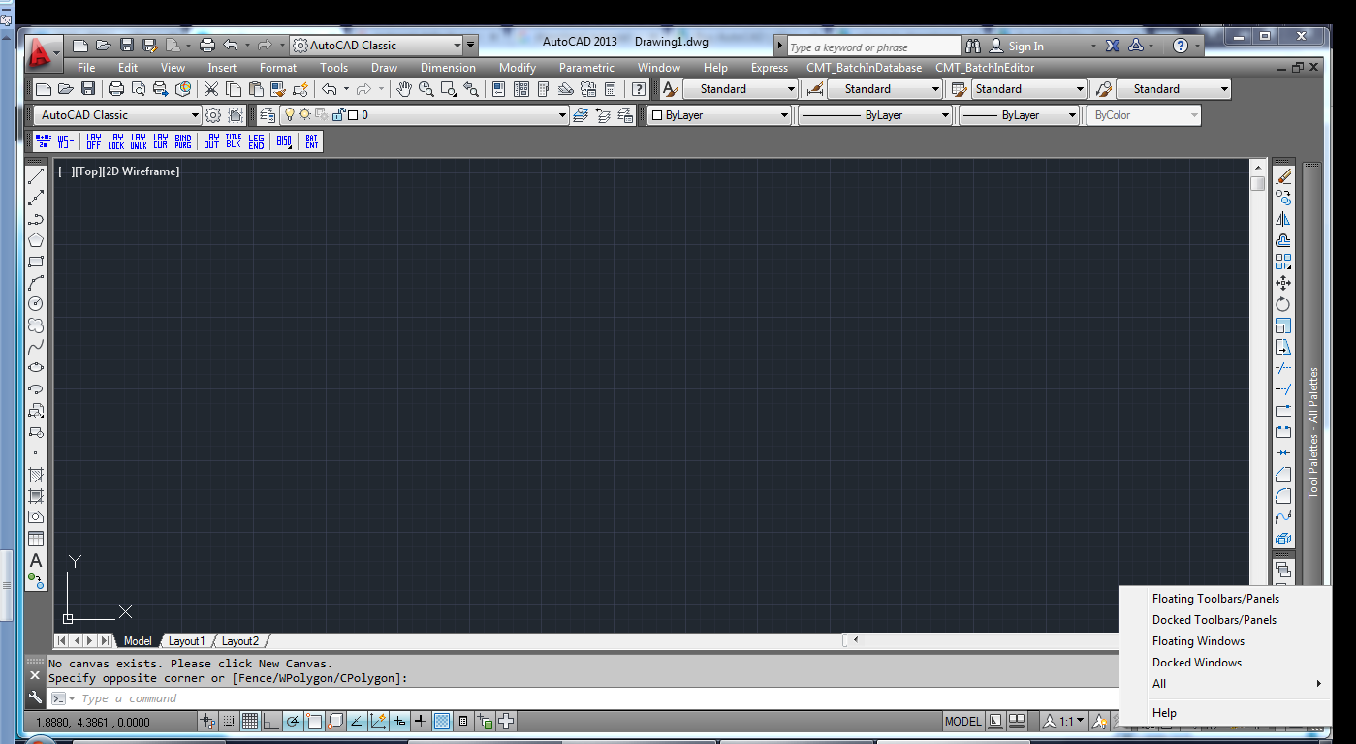

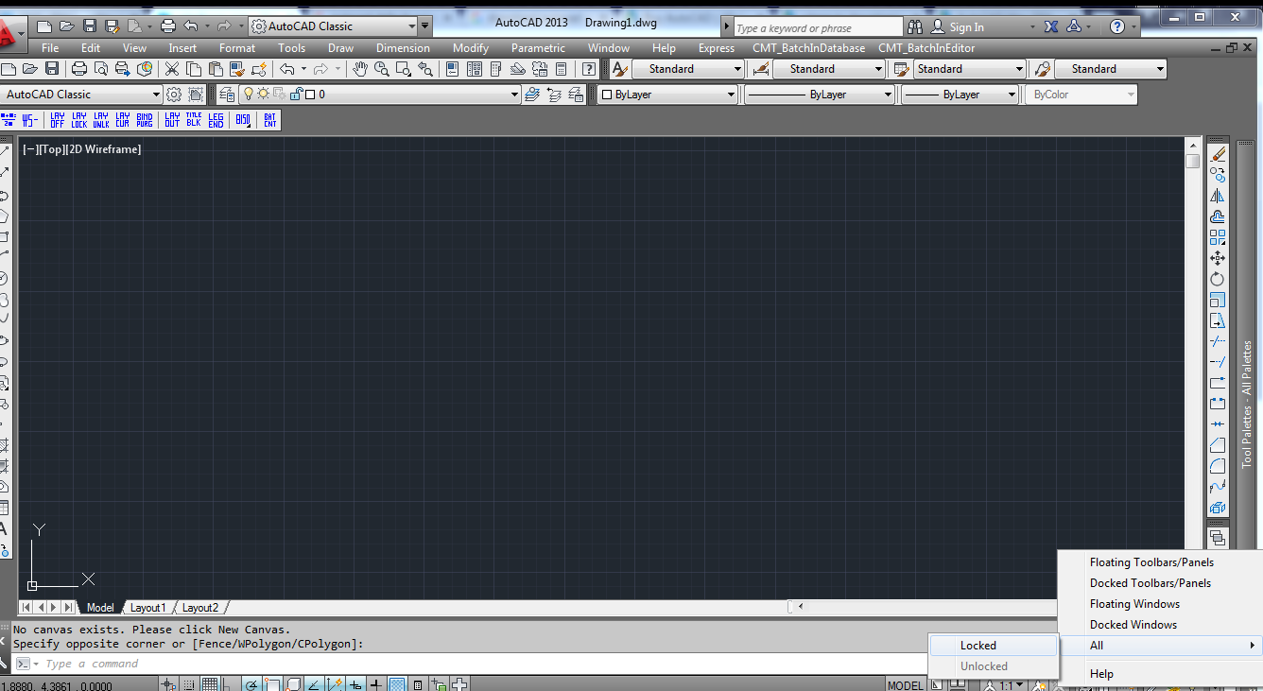

* 1. **Add Palettes**
     1. Make sure tool palettes are displayed (on the right hand side)
     2. Use (ctrl + 3) command to toggle the tool palette visibility if it is hidden
     3. Hover over the palette bar to open the fly away window
     4. Right click on the fly away window
     5. Select customize palette

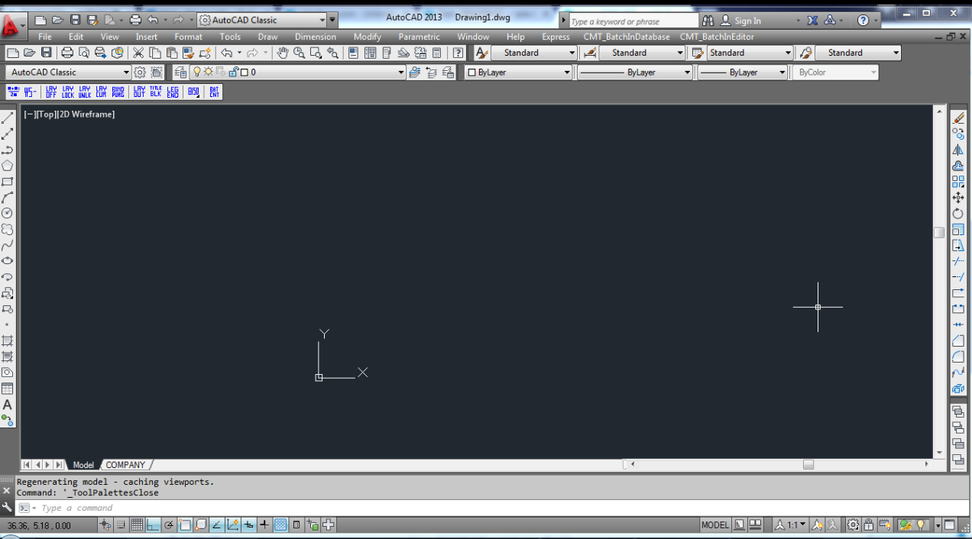

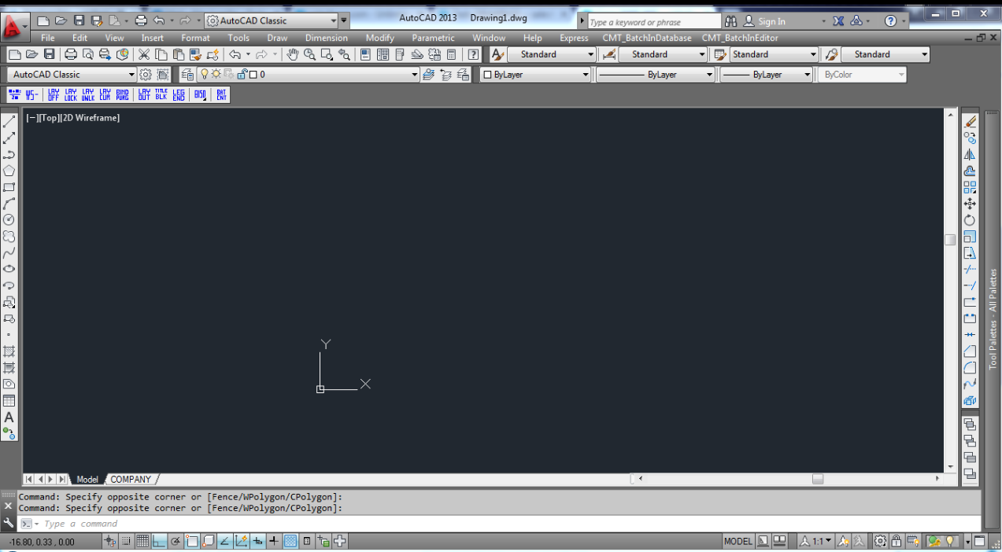

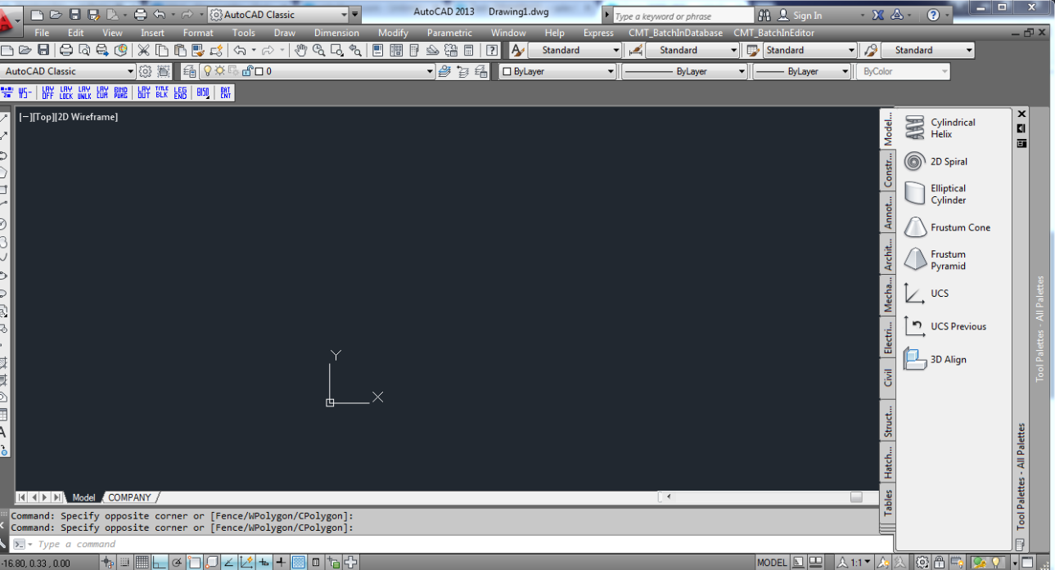

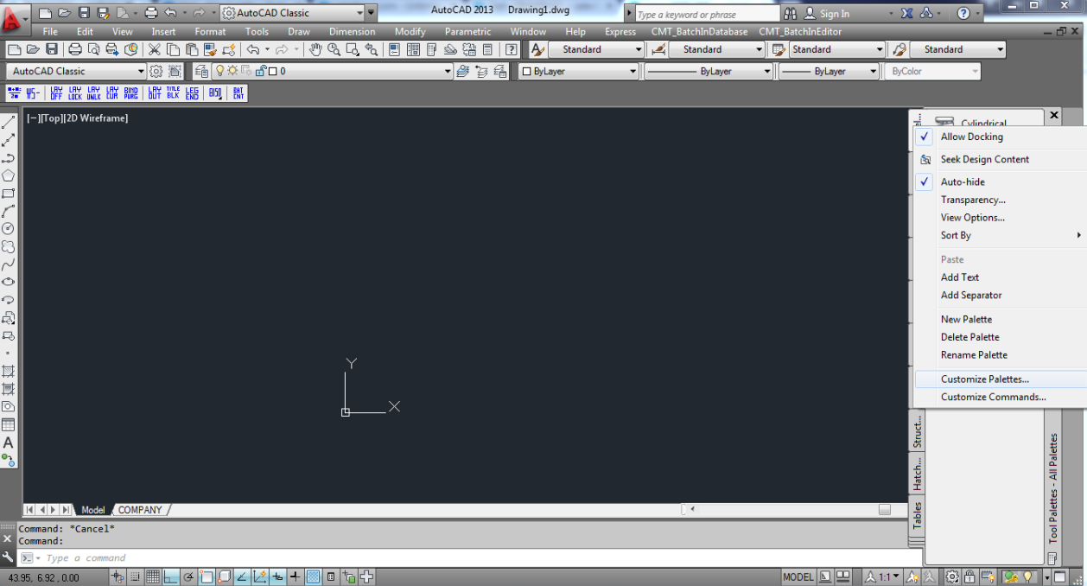

* + 1. On the left hand side there is a dialog box showing all available tool palettes
    2. Delete all the default AutoCAD tool palettes (Modeling, Constraints, ect.)
    3. Leave all the Lighting Controls tool palettes
    4. Full list here -> C:\WS_Blocks\Default\ToolPallete

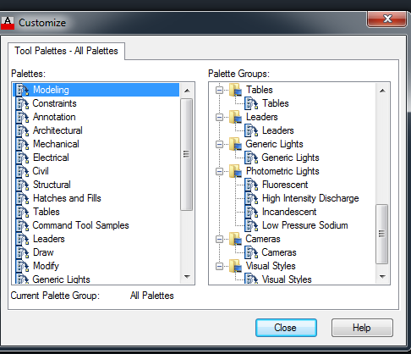

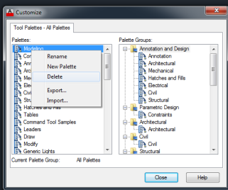

* + 1. On the right hand side there is a dialog box to import tool palettes groups
    2. Right click
    3. Select import
    4. Select the Palette Group.xpg
    5. Found here
    6. C:\WS_Blocks\Default\ToolPallete\Palettes
    7. Default Palette Group.xpg
    8. C:\WS_Blocks\Custom\ToolPallete\Palettes
    9. Custom Palette Group.xpg

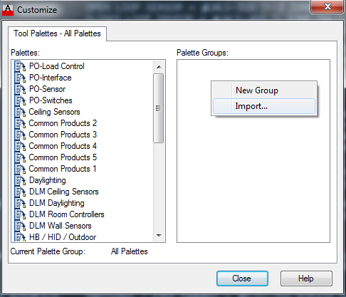

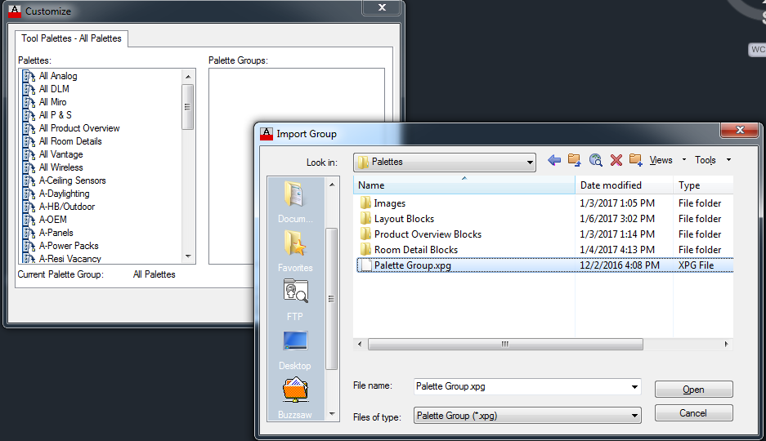

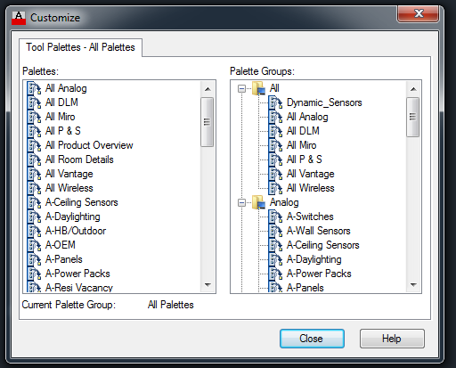

* 1. **Customize Quick Access Toolbar**
     1. Click the Customize Quick Access Toolbar (top left of screen)
     2. Check Workspace, Save, New, Open, Save As, Undo, Redo, Plot
     3. At this point you can go back into workspace settings and uncheck Automatically save workspace changes.

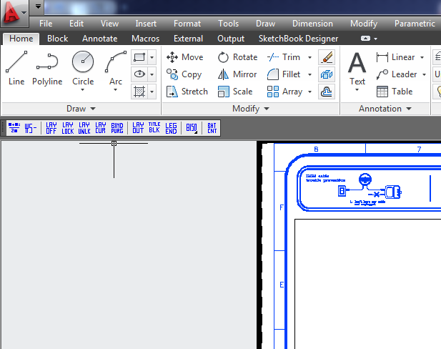

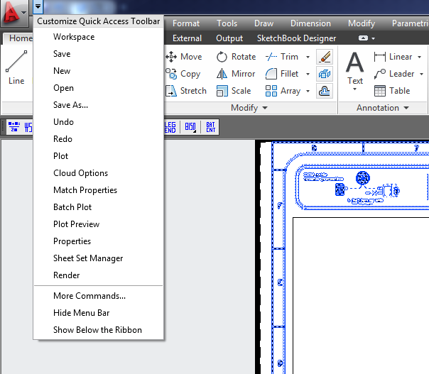

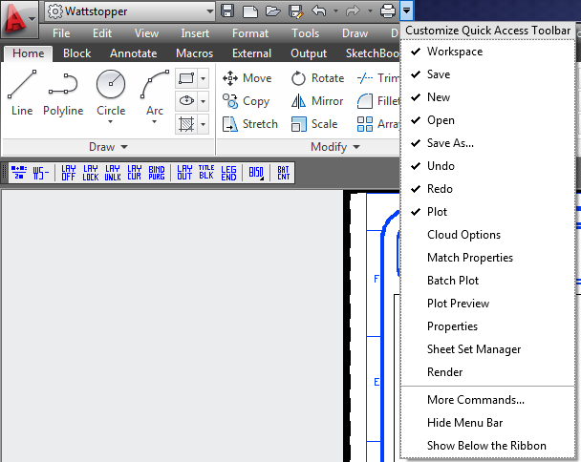

* 1. **Setup Complete**